May
2022
TSARTLIP YOUTH PROGRAM
Title  ACTIVITIES CLENDAR FOR THIS MONTH  **Importance Notice : Most places are no longer required to wear mask or show proof of vaccinations but there might be some places that are sitll need when it comes to vaccination, so please come prepare !  **Activity on May 30th & 31st will be the same as previous Mon & Tue | 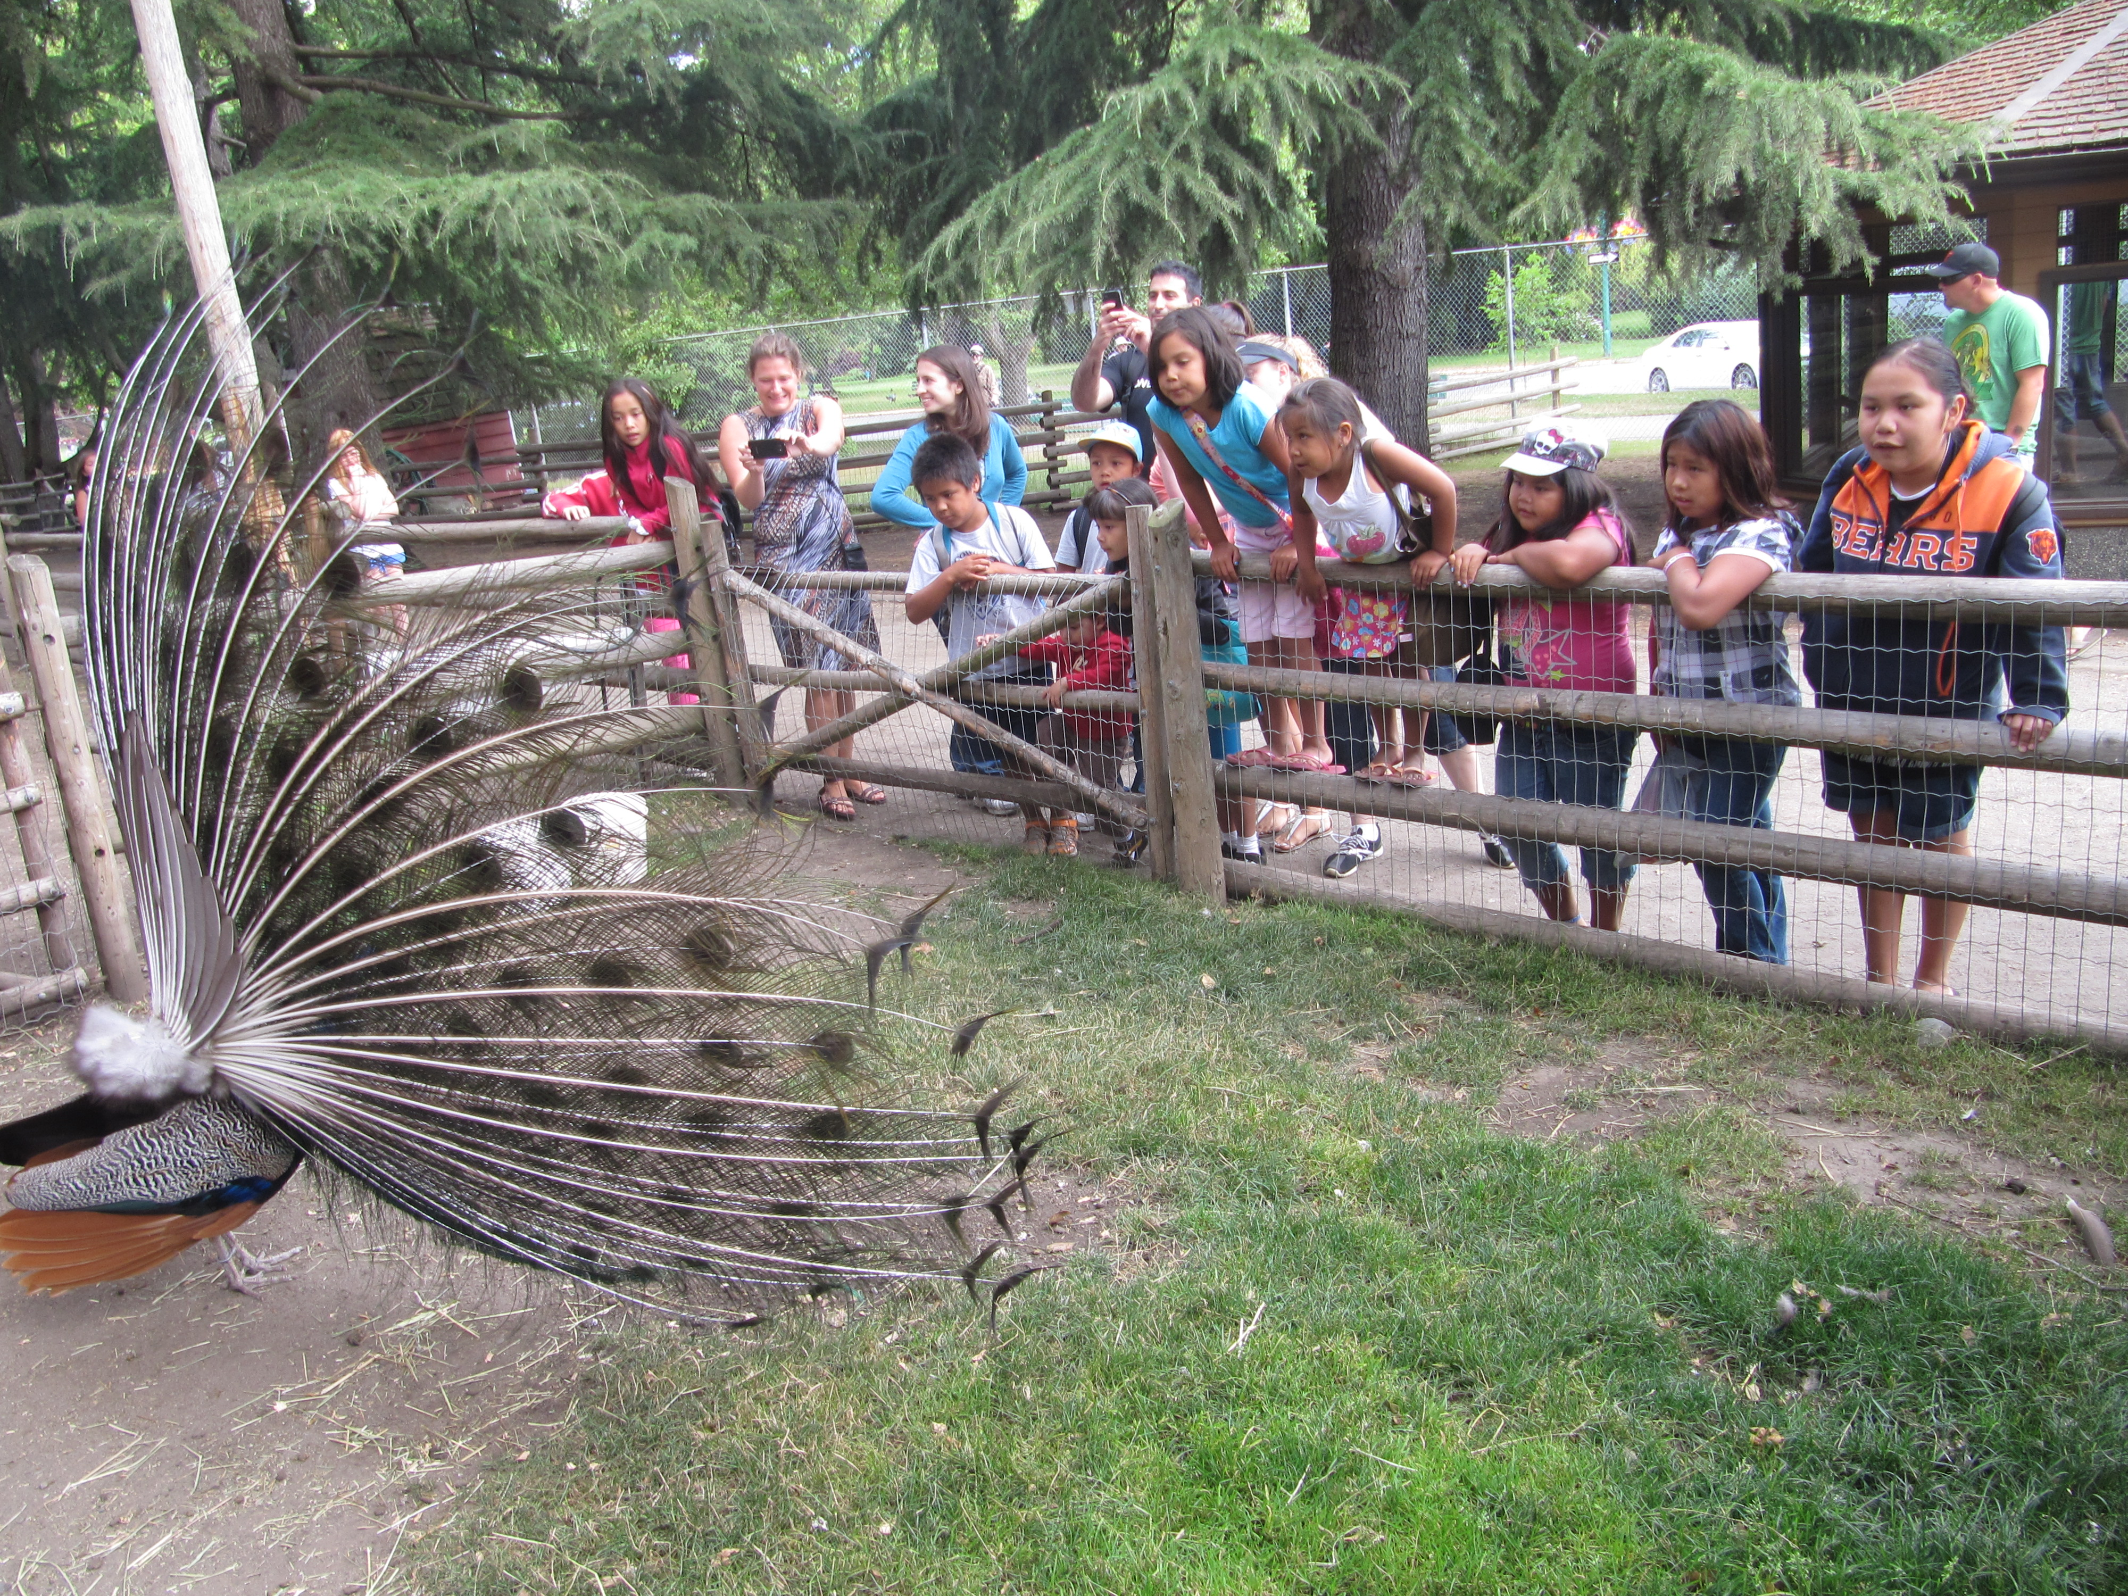
Sunday | Monday | Tuesday | Wednesday | Thursday | Friday | Saturday
1 | 2 | 3 | 4 | 5 | 6 | 7
 | H/work club @  Bayside sch. All students are welcome 3-5pm | -H/work club @  Tribal sch. All students are welcome  -H/work club @ Stelly’s sch for high school students, both at 3-5pm | Family swim nigh @ Panorama, bus comes around for pick up at 5:30pm | H/work club @ Stelly’s sch for high school students, everyone is welcome 3-5pm
8 | 9 | 10 | 11 | 12 | 13 | 14
 | H/work club @  Bayside sch. All students are welcome 3-5pm | -H/work club @  Tribal sch. All students are welcome  -H/work club @ Stelly’s sch for high school students, both at 3-5pm | Family swim nigh @ Panorama, bus comes around for pick up at 5:30pm | H/work club @ Stelly’s sch for high school students, everyone is welcome 3-5pm | Family movie nigh and little one, bus pick up at the Log cabin 3:15pm
15 | 16 | 17 | 18 | 19 | 20 | 21
 | H/work club @  Bayside sch. All students are welcome 3-5pm | -H/work club @  Tribal sch. All students are welcome  -H/work club @ Stelly’s sch for high school students, both at 3-5pm | Family swim nigh @ Panorama, bus comes around for pick up at 5:30pm | H/work club @ Stelly’s sch for high school students, everyone is welcome 3-5pm | Youth club (ages 13 & up only)  Meet at the Band office for an organize activity
22 | 23 | 24 | 25 | 26 | 27 | 28
 | H/work club @  Bayside sch. All students are welcome 3-5pm | -H/work club @  Tribal sch. All students are welcome  -H/work club @ Stelly’s sch for high school students, both at 3-5pm | Family swim nigh @ Panorama, bus comes around for pick up at 5:30pm | H/work club @ Stelly’s sch for high school students, everyone is welcome 3-5pm | Movie night for older youth ages 13 and up @ silver city, bus pick up at the log cabin 3:13pm
29 | 30 | 31
H/work club @
Bayside sch. All students are welcome 3-5pm

