April
2022
TSARTLIP YOUTH PROGRAM
Title  ACTIVITIES CLENDAR FOR THIS MONTH  **Importance Notice  All family swims or any outing indoor activities ;  You must have a proof of double vaccinations if you’re 12yrs & up. | 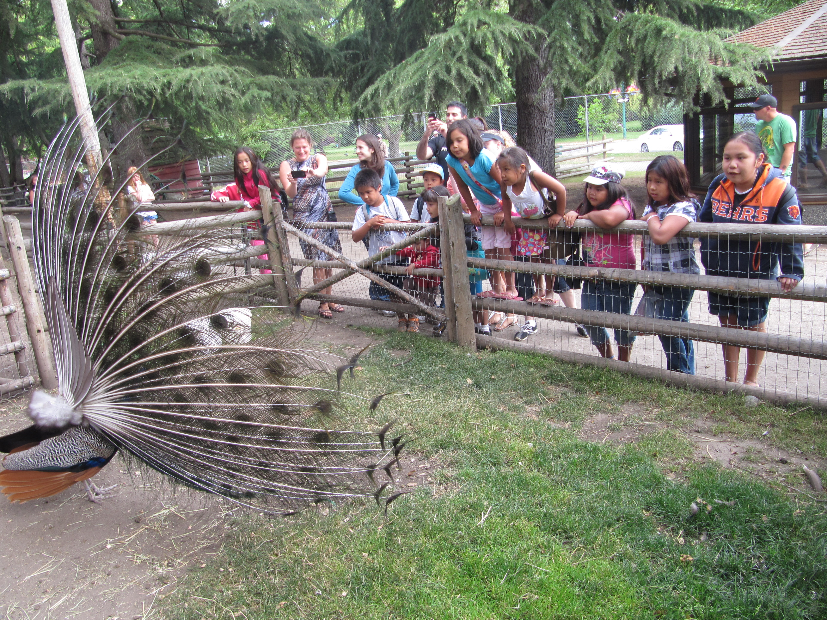
Sunday | Monday | Tuesday | Wednesday | Thursday | Friday | Saturday
 |  |  |  |  | 1 | 2
3 | 4 | 5 | 6 | 7 | 8 | 9
 | H/work club @ Bayside sch. All students welcome  3- 5pm | -H/work club @ Tribal sch, all students welcome.  -H/work club @ Stelly for high school students  Both at 3-5pm | Family swim night @ Panorama, bus comes around for pick up at 5:30pm | W/work club @ Stelly for high school students  3-5pm
10 | 11 | 12 | 13 | 14 | 15 | 16
 | H/work club @ Bayside sch. All students welcome  3- 5pm | -H/work club @ Tribal sch, all students welcome.  -H/work club @ Stelly for high school students  Both at 3-5pm | Family swim night @ Panorama, bus comes around for pick up at 5:30pm | W/work club @ Stelly for high school students  3-5pm
17 | 18 | 19 | 20 | 21 | 22 | 23
 | H/work club @ Bayside sch. All students welcome  3- 5pm | -H/work club @ Tribal sch, all students welcome.  -H/work club @ Stelly for high school students  3-5pm | OFF | W/work club @ Stelly for high school students  3-5pm
24 | 25 | 26 | 27 | 28 | 29 | 30
 | H/work club @ Bayside sch. All students welcome  3- 5pm | -H/work club @ Tribal sch, all students welcome.  -H/work club @ Stelly for high school students  Both at 3-5pm | Family swim night @ Panorama, bus comes around for pick up at 5:30pm | W/work club @ Stelly for high school students  3-5pm
View and edit this document in Word on your computer, tablet, or phone. You can edit text; easily insert content such as pictures, shapes, and tables; and seamlessly save the document to the cloud from Word on your Windows, Mac, Android, or iOS device.

